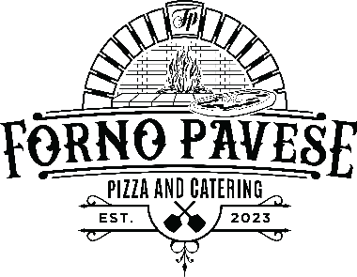

**Where Wood-Fired Dreams Become Family Traditions**

Experience a one-of-a-kind culinary adventure with our Pizza Napoletana, crafted with the finest locally-sourced and imported ingredients, including Italy's renowned San Marzano tomatoes, for an authentic and innovative taste. With our onsite catering package, we handle everything, providing plates and utensils to make your event hassle-free.

* 25-50 Guests: $20 per person (1-hour serving)
* 51-100 Guests: $17 per person (1.5-hour serving)
* 101-150 Guests: $14 per person (2-hour serving)
* 151-200 Guests: $13 per person (2-2.5 hour serving)
* Drinks Available: + $2.00 per person
* Travel Charge: Free within 30 miles from our home base. $200 every 30 miles additional

**Pizza choices**

**Cheese**

Topped with our San Marzano Tomato sauce, Grande whole milk mozzarella

**Margherita**

Topped with our San Marzano tomato sauce, fresh fior di latte, Parmigiano cheese and fresh basil

**Dolce Diavola**

Topped with our San Marzano tomato sauce, hot imported soppressata, Calabrian chili, whole milk mozzarella, Romano cheese and finished with local honey

**The Godfather**

Topped with our San Marzano tomato sauce, whole milk mozzarella, Italian beef, roasted sweet peppers, hot giardiniera, fresh garlic oregano and pecorino RomanoTop of Form

**My Kind of Town**

Topped with our San Marzano tomato sauce, whole milk mozzarella, Italian sausage, roasted sweet peppers, mushroom, onion, oregano and pecorino romano

**My Way**

Topped with our San Marzano tomato sauce, Pecorino Romano, whole milk mozzarella, double pepperoni, onion, garlic and oregano

**Summer Wind**

San Marzano tomato sauce, whole milk mozzarella, roasted sweet peppers, onion, mushrooms, garlic and Parmigiano

**Innamorata**

Olive oil base, fresh garlic, basil, whole milk mozzarella, fontina, Parmigianino reggiano and whipped ricotta cheese

**Thats Amore**

Olive oil base, basil, spinach, mushroom, fresh garlic, whole milk mozzarella